Question 1
- Describe the data set using the one in the package MASS

?crabs

The crabs data frame has 200 rows and 8 columns, describing 5 morphological measurements on 50 crabs each of two colour forms and both sexes, of the species Leptograpsus variegatus collected at Fremantle, W. Australia.
This data frame contains the following columns:
sp: species - "B" or "O" for blue or orange.
Sex: as it says.
Index: index 1:50 within each of the four groups.
FL: frontal lobe size (mm).
RW: rear width (mm).
CL: carapace length (mm).
CW: carapace width (mm).
BD : body depth (mm).
Source: Campbell, N.A. and Mahon, R.J. (1974) A multivariate study of variation in two species of rock crab of genus Leptograpsus. Australian Journal of Zoology 22, 417–425.

- Load the dataset and display its structure
str(crabs)

data.frame': 200 obs. of 8 variables:
$ sp : Factor w/ 2 levels "B","O": 1 1 1 1 1 1 1 1 1 1 ...
$ sex : Factor w/ 2 levels "F","M": 2 2 2 2 2 2 2 2 2 2 ...
$ index: int 1 2 3 4 5 6 7 8 9 10 ...
$ FL : num 8.1 8.8 9.2 9.6 9.8 10.8 11.1 11.6 11.8 11.8 ...
$ RW : num 6.7 7.7 7.8 7.9 8 9 9.9 9.1 9.6 10.5 ...
$ CL : num 16.1 18.1 19 20.1 20.3 23 23.8 24.5 24.2 25.2 ...
$ CW : num 19 20.8 22.4 23.1 23 26.5 27.1 28.4 27.8 29.3 ...
$ BD : num 7 7.4 7.7 8.2 8.2 9.8 9.8 10.4 9.7 10.3 ...

head(crabs)
sp sex index FL RW CL CW BD
1 B M 1 8.1 6.7 16.1 19.0 7.0
2 B M 2 8.8 7.7 18.1 20.8 7.4
3 B M 3 9.2 7.8 19.0 22.4 7.7
4 B M 4 9.6 7.9 20.1 23.1 8.2
5 B M 5 9.8 8.0 20.3 23.0 8.2
6 B M 6 10.8 9.0 23.0 26.5 9.8

- Produce frequency table for species and sex
freq_table<- table(crabs$sex, crabs$sp)
freq_table

B O
F 50 50
M 50 50

- Bar chart
barplot(freq_table, beside = TRUE, legend = TRUE, col = c("blue",
"red"), main = "Frequency of Crabs by Sex
and Species", xlab = "Species", ylab = "Frequency")
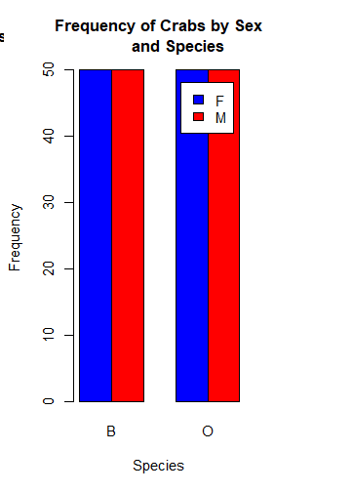

- The dataset is balanced because from the bar chart above, there are equal number of species across the sex.

Question 2
- Boxplots of body depth for the four groups defined by species and sex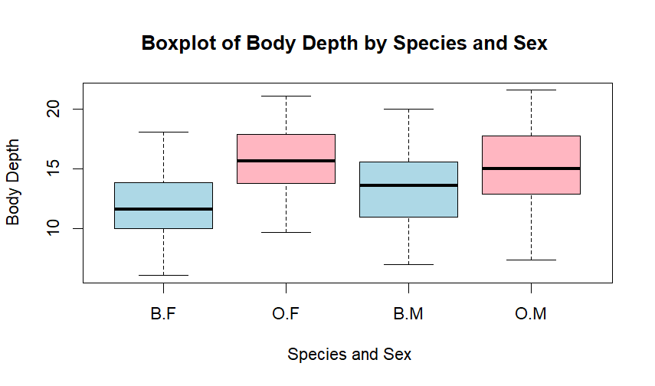
boxplot(crabs$BD~sp+sex,data = crabs, main = "Boxplot of Body Depth by Species and Sex ",
xlab = " Species and Sex", ylab = "Body Depth",
col = c("lightblue", "lightpink"))
- Identify any outliers and compare the central tendency and variability between the group
outliers <- boxplot(crabs$BD~sp+sex, data = crabs, plot = FALSE)$out
outliers

numeric(0)

summary(crabs$BD)
by(crabs$BD, list(crabs$sp, crabs$sex), summary)
by(crabs$BD, list(crabs$sp, crabs$sex), var)

summary(crabs$BD)
Min. 1st Qu. Median Mean 3rd Qu. Max.
6.10 11.40 13.90 14.03 16.60 21.60
by(crabs$BD, list(crabs$sp, crabs$sex), var)
: B
: F
[1] 7.576065
-----------------------------------------------------------------
: O
: F
[1] 7.576914
-----------------------------------------------------------------
: B
: M
[1] 10.23929
-----------------------------------------------------------------
: O
: M
[1] 12.44104

Question 3
- Histograms of carapace length for each species
par(mfrow=c(1,2))
hist(crabs$CL[crabs$sp == "B"], main = "Carapace Length Distribution for Species B", xlab = "Carapace Length", col = "lightblue")
hist(crabs$CL[crabs$sp == "O"], main = "Carapace Length Distribution for Species O", xlab = "Carapace Length", col = "lightpink")
par(mfrow=c(1,1))

- From the plot above species B is right skewed and species O is left skewed.
skewness_B <- e1071::skewness(crabs$CL[crabs$sp == "B"])
skewness_B
0.02571518

skewness_O <- e1071::skewness(crabs$CL[crabs$sp == "O"])
skewness_O
-0.1536776

Question 4
- Mean of each morphological measurement (CL, CW, BD, FL, RW) by species and sex
mean_values <- aggregate(cbind(CL, CW, BD, FL, RW) ~ sp +sex, data = crabs, FUN = mean)
mean_values

sp sex CL CW BD FL RW
1 B F 28.102 32.624 11.816 13.270 12.138
2 O F 34.618 39.036 15.632 17.594 14.836
3 B M 32.014 36.810 13.350 14.842 11.718
4 O M 33.688 37.188 15.324 16.626 12.262

- grouped bar chart to display these means
barplot(t(as.matrix(mean_values[,-c(1,2)])), beside = TRUE, legend = TRUE, col = c("lightblue", "lightpink"), main = "Mean Morphological Measurements
by Species and Sex", xlab = "Species and Sex", ylab = "Mean Value", names.arg = paste(mean_values$sp, mean_values$sex, sep = "-"))

species_diff <- apply(mean_values[,-c(1,2)], 2, function(x) max(x) - min(x))
species_diff

CL CW BD FL RW
6.516 6.412 3.816 4.324 2.698

variation <- apply(mean_values[,-c(1,2)], 2, function(x) abs(x[1] - x[2])/species_diff
)
Variation

CL CW BD FL RW
CL 1.000000 0.9840393 0.5856354 0.6635973 0.4140577
CW 1.016220 1.0000000 0.5951341 0.6743606 0.4207735
BD 1.707547 1.6802935 1.0000000 1.1331237 0.7070231
FL 1.506938 1.4828862 0.8825162 1.0000000 0.6239593
RW 2.089801 2.0564464 1.2238614 1.3867864 0.8652983

Question 5
- Scatterplot matrix (pairs plot) of the five measurements
pairs(crabs[ c("CL", "CW", "BD", "FL", "RW")], main = "Scatter Plot Matrix of Morphological Measurements", pch = 19, col = ifelse(crabs$sp == "B", "lightblue", "lightpink"))

- The strength and nature of the relationships among variables
cor_matrix <- cor(crabs[ c("CL", "CW", "BD", "FL", "RW")])
cor_matrix

CL CW BD FL RW
CL 1.0000000 0.9950225 0.9832038 0.9788418 0.8927430
CW 0.9950225 1.0000000 0.9678117 0.9649558 0.9004021
BD 0.9832038 0.9678117 1.0000000 0.9876272 0.8892054
FL 0.9788418 0.9649558 0.9876272 1.0000000 0.9069876
RW 0.8927430 0.9004021 0.8892054 0.9069876 1.0000000

The scatter plot matrix shows strong, positive and approximately linear relationships among all morphological variables (CL, CW, BD, FL, and RW). From the plot, as one measurement increases, the others also increase, which shows a positive correlation and consistent body size scaling. There was no major outliers observed.

Question 6
The crabs dataset Modern Applied Statistics with S package contains 200 observations of the crab species Leptograpsus variegatus, with measurements recorded for two species (Blue and Orange) and two sexes (Male and Female). The dataset includes five morphological variables ( carapace length (CL), carapace width (CW), body depth (BD), frontal lobe size (FL), and rear width (RW)). The frequency table of species and sex shows that the data is balanced, because 50 males and 50 females in each species, giving 100 crabs per species and 200 in total. This balanced design allows for fair comparison between groups without sample size bias. Boxplots of body depth (BD) across the four species–sex groups show that males generally have higher median body depth than females within both species. The variability in body depth appears similar across groups, and no extreme outliers are evident. Histograms of carapace length (CL) for each species show approximately symmetric and unimodal distributions. Both species display slight positive skewness, with a small number of larger crabs extending the right tail. The shapes of the CL distributions for Blue and Orange species are broadly similar, indicating comparable growth patterns. The mean values of all five morphological measurements (CL, CW, BD, FL, RW) are consistently higher in males than in females for both species. Differences between species exist but are less pronounced than differences between sexes. The scatter plot matrix of the five morphological variables reveals very strong positive linear relationships among all measurements. The data points cluster tightly around straight lines, indicating high correlation and proportional growth among body dimensions. Overall, the analysis demonstrates clear sexual dimorphism, similar distributional patterns between species, and strong positive linear associations among all morphological measurements, reflecting consistent allometric scaling in the crabs.

